Solar Panel

Gallaudet University

800 Florida Ave Ne

Washington D.C. 20002

Dear Caroline Solomon,

Thank you for taking the time with us during the class. We know that the university is working on installing solar panels to lower the cost of electricity and encourage the growth of renewable energy sources. So our focus is to partner with the university and help research how solar panels will be beneficial in our community.

We are delighted to enclose our Group project, which is the installation of solar panels at Gallaudet University. Our project is based on researching how solar panels impact Buildings in several ways and seeing what positive and negative outcomes of installing solar panels. Inside, the findings and information explain our project aims and the preliminary results. We have collected and analyzed the data from Washburn Arts Center Building and found an electric increase each year, which shows that solar panels would be beneficial by reducing the cost. We will install solar panels in the Washburn Art Center Building to collect data and compare the differences. We will also calculate the total need for purchase, installation, and maintenance, which will give us the difference and show how solar panels would be beneficial in the future.

Attached is the research of our proposed project. We look forward to discussing this project with you in more detail in the near future.

Sincerely,

Mbisana Kgakgamatso, Dylan Christoffels, Larry Daniel, David Malle, and Elina Rubinshteyn.

Gallaudet University

Solar Panel Project

Submitted by:

Dylan, Larry, David, Elina, and Mbisana

Submitted on:

December 15, 2021

**Abstract and Specific Aims**

Solar panels are becoming more popular and advancing rapidly worldwide because the energy generated from solar panels will benefit people in the long term. We researched and found that many universities use solar panels to reduce their cost of electricity. Gallaudet University could do the same thing. However, during the data collection process, we found that Gallaudet is already in the process of installing solar panels on the campus for the community around the campus. Washburn Art Building (WAB) had electricity usage, which we used to calculate potential energy from solar panels. Our project focuses on predicting the potential solar panel energy that will cover the WAB electricity usage.

**Background**

Gallaudet needs more diverse energy sources. They already have some small solar which was never used to benefit the campus. So Installing more solar panels can be advantageous. For example, solar panels help reduce air pollutants, reduce water usage, help fight climate change, reduce dependency on renewable energy sources, improve humanity’s health in the long run and also our University’s lead could inspire other groups in the area to invest in solar energy that does benefit Gallaudet community.

The issue is that Gallaudet does not have its solar panels to save electricity and money, which will promote and profit the community. We believe that Gallaudet can save so much money by installing solar panels. According to the article [6], the advantage is to sell the power to the state, solar panels are safe, and nothing risks it. Electricity is made from natural gas and coal, which is costly, and the risk of accidents is high compared to environmentally friendly solar panels. The data collected will be able to help know how much energy would be saved.

This project aims to find and collect data on solar panels, which will provide evidence indicating why solar panels are beneficial to Gallaudet University. The research increases collection efficiency by developing a device that tracks the sun to keep the panel at a right angle. The tracker is designed on a new principle of using tiny solar cells to function as self-adjusting light sensors and providing a variable stimulation of their relative angle to the sun by detecting their voltage output [6]. Saitov et al. [7] explain that a group of people analyze solar panels and calculate how they will benefit the Tashkent State Technical University. They calculate and claim that the University will profit 50 euros each month, which means University will benefit by earning much money through the years. Compare the 50 euros to US dollars is $56.32. We plan to figure out what size space on the WAB roof can be used to install solar panels and then calculate the energy benefits for WAB building and community.

**Research Design**

Our preliminary research shows that solar panels impact universities in several ways and see the positive and negative outcomes of installing solar panels. Due to the shortage of time, we decided to focus on solar panel production itself, covering the WAB building. The solar panels' tool energy converter and collect data were difficult to find, so we contacted the solar panel companies in DC to help us find the best way to get the data. It will help us calculate and find the data to make predictions for Gallaudet University.However, we did not receive any message from the companies we contacted. Therefore, we decided to change our plan to mirror Boston College's plan. We use a study from Boston College [3] to identify strategies and find data on electricity usage with space for solar panels that will cover the roof. To do that, we need to calculate the total possible earnings that will cover electricity usage and how much profit will the WAB building get in the future.

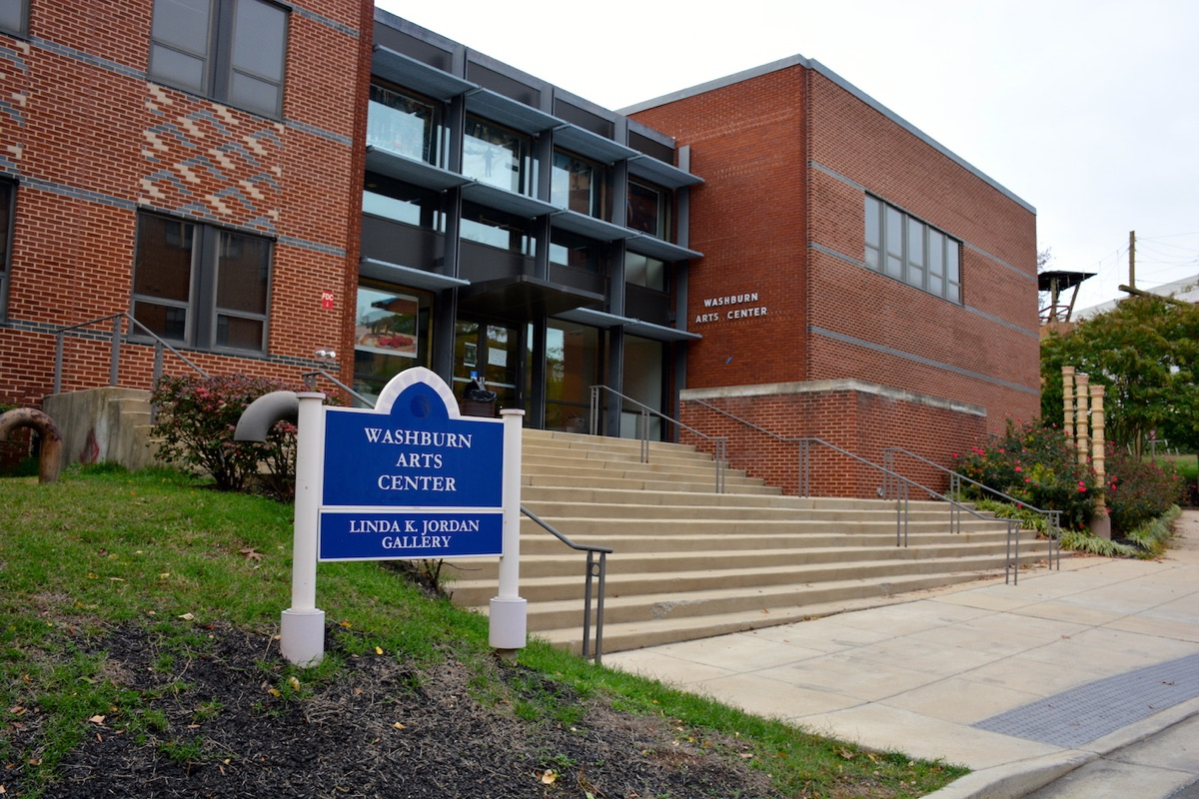

**Figure 1.** *Picture of the Washburn Building (WAB) “Washburn Arts Center”*

The picture Fig. 1 shows the Washburn Arts Center building (WAB), where we mainly focus on for our research about whether solar panel energy covers the WAB usage of electricity.

We calculate how much solar panel we need to have on our WAB building using a website (Understand Solar) [4].

“AC rating = Average kWh per month / 30 days / average sun hours per day.

Example: 903 kWh per month / 30 days / 5 hours = 6.02 kW AC

DC rating = AC rating / derate factor (.8 is conservative, but a range would be .8 – .85)

Example: 6.02 kW AC / .8 = 7.53 kW DC

Number of panels = DC rating / Panel Rating (e.g., 25o W) *note this is important b/c panels are rated in watts, and the systems are rated in kilowatts (1000 watts). So a 7.53 kW system = 7530 Watts and a 250 watt panel = .250 kW

Example: 7.53 kW x 1000 / 250 watt = 30.12 panels, so roughly 30 250 panels (30 x 250W = 7500 Watts = 7.5 kW)”

As a result, We calculated our solar panel estimate by the months we needed on the WAB building. Therefore, we need 24 solar panels to meet our goals to save our electricity and benefit our Gallaudet community.

**Preliminary Results**

We collected information about the size of the roof on WAB, where solar panels could be installed. We obtained data on electricity usage in WAB from 2016 to 2019 from the Energy & Sustainability Department. We calculated the data with the space of the WAB roof to see how many installed solar panels will fit on the WAB roof. Our calculation shows that 24 solar panels will fit on the roof. We were also interested to see if the solar panel's energy will cover the WAB electricity usage.

|  |  |  |  |  |  |  |  |  |  |  |  |  |  |
| --- | --- | --- | --- | --- | --- | --- | --- | --- | --- | --- | --- | --- | --- |
|  | | **Months** | | | | | | | | | | | |
| **January** | **February** | **March** | **April** | **May** | **June** | **July** | **August** | **September** | **October** | **November** | **December** |
| **Years** | **2016** | 36.22 | 31.34 | 29.65 | 33.52 | 28.46 | 30.61 | 33.8 | 34.25 | 33.11 | 34.26 | 31.79 | 31.84 |
| **2017** | 30.39 | 30.96 | 30.71 | 32.8 | 30.85 | 32.17 | 34.22 | 34.08 | 35.53 | 35.02 | 36.19 | 36.99 |
| **2018** | 37.52 | 33.01 | 3.92 | n/a | n/a | n/a | 6.12 | 30.72 | 32.93 | 34.3 | 34.26 | 32.13 |
| **2019** | 28.65 | 33.6 | 29.36 | 31.38 | 30.93 | 37.59 | 35.96 | 32.27 | 31.35 | n/a | n/a | n/a |

**Table 1.** *Average consumption of energy in watts from 2016-2019 at the Washburn Arts Building*

Table 1 shows the average watts from Washburn Building in Gallaudet University taken every month each year from 2016 to 2019. We noticed that no data was collected in 2018 from April to June, and also, there is missing data in 2019 from October to December, which will affect our results. Also, we noticed that there might be a mistake in 2018 in March and July because the data is too low and different from the total average of each month.

According to the article [6], the advantage is to sell the power to the state, solar panels are safe, and nothing risks it. If you consume 200-400 kW/h per month, you will benefit from installing solar panels in the average total.

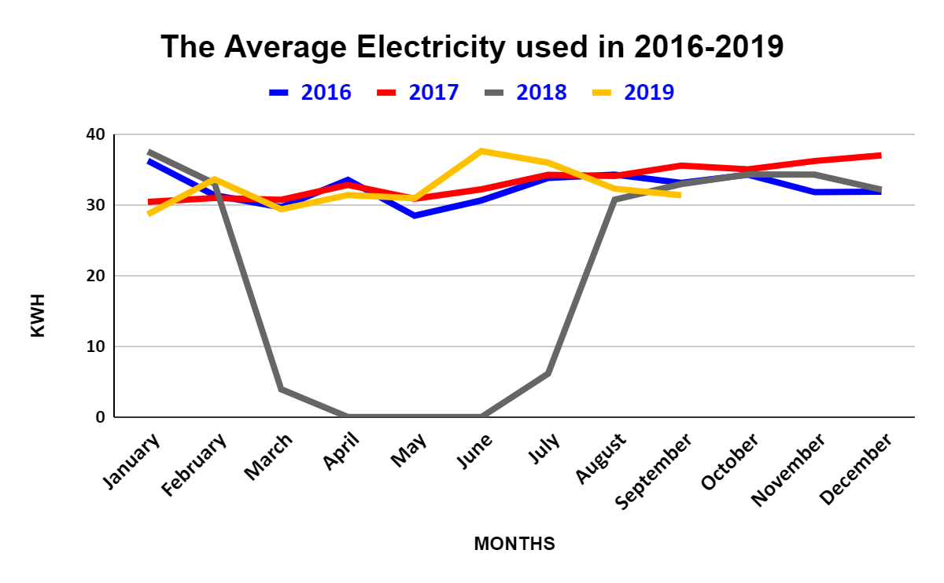

**Figure 2.** *Line graph shows years and months to see how many kilowatt hours (KWH).*

As seen in Fig. 2, The amount of electricity used in 2016 is low compared to the one used in 2017. During 2016 and 2017, the energy consumption varies slightly from February to April and then increases for the rest of the year (Figure 2). The data for the year 2018 had mistakes and therefore is incomplete from March to July. Finally, for 2019, we see that the electricity usage was twice between January to February and May to June.

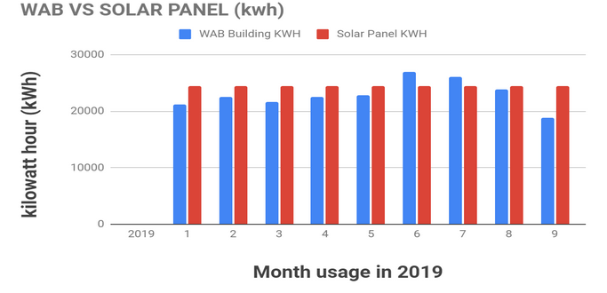

**Figure 3.** *Compare between WAB building usage and solar panel produce watts*

As seen in Fig. 3, the amount of electricity used in WAB is compared to the amount of energy produced by solar panels. WAB building electricity usage and solar panels generated watts. This graph shows that solar panels benefit our electricity storage from January until September 2019. The data of solar panels KWH are displayed as the max produce of the watts. In the future might need to add more panels depending on the sunlight through the years. The data show only in 2019 and 9 months between January to September. It shows that solar panel watts cover WAB watts usage most of the month to show that it benefits coverage, so you do not need to pay the electricity bill. It shows that only June and July months usage of WAB increased and that more than solar panel KWH produce. Total energy from the panels will cover the energy usage in WAB. It is only two months out of 9 months which is good stats and outcome. Gallaudet University will pay only the amount of noncoverage by Solar Panel KWH that is way cheaper than actually paying the whole electricity usage WAB in one month.

**Budget**

We will need to get measurements of the WAB roof to find the best possible Solar Panels, including the size that can fit the roof that comes with a cost. That is where we will need to pay for solar panels. In the future, we will benefit from it by reducing the electricity bill by solar panel use in WAB then using that money to pay off solar panel costs.

According to the District of Columbia (from EnergySage and Solar Reviews) [5], from 2019, the estimated standard starting cost for a 6-kW system is $14,000 for each solar panel. Install on the WAB building will be perfect for installing 24 solar panels on the roof. The total is $336,000, which does not include labor, which is pretty expensive. However, according to our chart (Figure 2) "WAB VS Solar Panel," Gallaudet University needs to consider our environment and save money. The graph proves that Solar panels preserve more electricity usage, the more saving electricity, the costs will be less than we expected. Therefore, Gallaudet University will save more money.

Holowka T. [2] explains the four benefits of solar panels in homes. Nevertheless, three benefits can be applied to Universities. The first is to reduce the electrical energy bill. Second, earning the tax credits will save $7,500 solar system worth $25,000. Last, that will help us and the environment by cleaning the air and will reduce dependence on fossil fuel.

**References**

[1] Boldyrev, А. А., & Herasymenko, N. V. (2020). *The usage of solar panels advantages and disadvantages* (Doctoral dissertation, ВНТУ).

[2] Holowka, T. (n.d.). *Top four benefits of installing solar panels on your home*. U.S. Green Building Council. Retrieved October 27, 2021, from https://www.usgbc.org/articles/top-four-benefits-installing-solar-panels-your-home.

[3] Meyer, A., Zaman, F., & Norton, E. (2014, April 1). A Case Study: Solar Panels at Boston College. Chestnut Hill; https://www.bc.edu/content/dam/files/schools/cas_sites/envstudies/pdf/Student%20Research/8_Solar_Panels_at_Boston%20College_paper.pdf

[4] Osman, Nadia. “Calculating the Kilowatt Hours Your Solar Panels Produce (Solar Panel Output).” *Understand Solar*, 5 Mar. 2015, https://understandsolar.com/calculating-kilowatt-hours-solar-panels-produce/.

[5] Parkman, K. (2021, November 19). How much do solar panels cost? Retrieved December 13, 2021, from https://www.consumeraffairs.com/solar-energy/how-much-do-solar-panels-cost.html

[6] Rizk, J., & Chaiko, Y. (2008). Solar Tracking System: More Efficient Use of Solar Panels. Retrieved October 26, 2021, fromhttp://citeseerx.ist.psu.edu/viewdoc/download?doi=10.1.1.306.7087&rep=rep1&type=pdf

[7] Saitov, E. B., Toshov, J. B., Pulatov, A. O., Botirov, B. M., & Kurbanov, Y. M. (2020). Networked interactive solar panels over the roof photovoltaic system (PVS) and its cost analysis at Tashkent State Technical University. In *E3S Web of Conferences* (Vol. 216, p.01133). EDP Sciences.

**Dylan Christoffels**

800 Florida Avenue NE, #803

Washington, D.C. 20002

Dylan.Christoffels@gallaudet.edu

**Objective**

To work in the Information Technology field, where I can enhance my knowledge and apply my technical skills

**Education**

Gallaudet University, Washington, D.C*.*:B.S. in Information Technology, expected May 2022: Cumulative GPA: 3.82

**Honors**

The National Society of Leadership and Success 2019-Present

Dean Prestige Scholarship through Gallaudet University 6 Consecutive Semesters

United East All-Sportsmanship Team for soccer 2021

National Honor Society                                 2016-2018

Deaf Youth Leadership Award MSAD                        2017

**Experience**

**Gallaudet University, Student Supervisor Customer Service Assistance** Summer 2021-Present

**Gallaudet University, Customer Service Assistance** 2019-Summer 2021

*Washington, DC (and virtual)*

* Hold weekly meetings with three other student supervisors to discuss streamlining computer lab operations
* Provide student and staff with instructional assistance in the use of both PC and Apple computers and software applications such as video editing, Word, Google applications, and PowerPoint presentations
* Ensure labs are orderly and clean with functional computers and printers
* Provide virtual support to customers through Zoom, Virtual Live Chat utilizing a ticket system through Service-Now

**Internship REU AICT at Gallaudet University (Remote) Supervisor: Dr. Raja Kushalnagar** Summer 2021

* Research on caption metrics and accuracy of captioned media
* Involved in the development of an assessment, and evaluate results
* Required to present weekly results and a final presentation on the evaluation of results

**Internship Access Framingham, Production Assistant** 2017-2018

*Framingham, MA*

* Edited films using Final Cut Pro
* Recorded school and local events
* Produced and set up in-studio shoots

**Activities**

Gallaudet University Men’s Soccer Team (*Team Captain* 2021) 2018-Present

Student-Athlete Advisory Committee (Rep. Men’s Soccer team: Parliament Position) 2019-Summer 2021

Varsity Men’s Soccer and Basketball Team (*Team Captain* 2015-18)                  2014-2018

Member, Representative, Treasurer and Vice-President of Student Body Government (SBG) 2015-2018

Member of Jr.NAD (Jr. National Association of the Deaf): (President 2017-18)                2016-2018

**Skills**

Fluent in American Sign Language (ASL) and written English; Web Design; Problem solver; Fast learner of new technology applications; Attentive to detail; Patient; Self-starter; Effective team leader; Works well with others; Familiarity with computer hardware components; participant in various on-line multi-player games

**Technical Skills**

**Operating Systems -** Windows 10, Mac OS X, Linux

**Applications -** Microsoft Access, Excel, Movie Maker, PowerPoint, Word, iMovie, Final Cut Pro, Google

**Languages -** Python, Java, Html, CSS, SQL, currently learning Swift UI

Elina Rubinshteyn

512-689-6224 / 10205 Laurie Lane Austin, TX 78747 /

elina.rubinshteyn@gallaudet.edu

**Objective**

Recent graduated with a Bachelor of Public Health, to use my skills, training, and experiences to secure a position as a Public Health Specialist.

**Education**

Gallaudet University, Washington D.C

Bachelor’s in science of Public Health, May 2022 / Cumulative GPA: 3.0

**Public Health Work Experience:**

**Planned Parenthood –– January 2021 to May 2021**

• Created content for social media featured on social media platforms

• Created interactive educational opportunities for youth children

• Participated in Black Women’s Wellness, events, and community meetings to bring awareness to District

**Public Health Covid Task Force – March 2020 to August 2020**

• Developed educational videos related to Covid prevention for Gallaudet students and campus members • Developed Covid educational content for #canthevirus Instagram page (ASL)

• Created interactive educational opportunities for students

**Other Work Experience:**

**Tutor - Gallaudet University — April 2019 to Present**

• Assisted the undergraduate students by helping their assignments

• Instructed students in the use of effective study, video, and essay strategies for academic improvement

**Carl’s Family Village- Brooklyn, Michigan — July 2019**

• Summer camp counselor for 3 weeks to deliver a fun, safe and effective camp experience for kids • Lead as a role mole for all deaf and hard of hearing kids

**Assist, EuroClean- Austin, Texas — September 2017 to August 2018**

• Performed sanitation duties such as vacuuming, dusting, cleaning windows and tables, mopping the floor and changing trash can at different companies.

**Certifications:**

CPR & First Aid

**Additional Activities:**

• Class of 2021 Design Jersey Committee 2019 • Gallaudet Volleyball Clinic in Austin, TX 2019 • Volleyball Camp at Texas School for the Deaf 2019 • Gallaudet University 5K Fundraiser 2019 • Helped Save The Green Program 2017 • Gave a presentation about Deaf Smith at Capital, Austin, TX 2017

**Skills:**

• Fluent in American Sign Language (ASL) and English

• Adaptability

• Understanding Trends

• Strong Interpersonal Skills

• Problem Solving Skills

• Effective Written and Verbal Communication

**Honors, Awards, Memberships and Conferences:**

• SAAC Represent for Gallaudet University Volleyball Team – 2018’19-2019’20 • Dean list – 2019

• Prom Committee Chairperson – 2017

• ServSafe National Restaurant Association- Certificate of Completion - 2017 • Youth Leadership Camp – 2016

• Poetry Slam into First Place and Publication in Texas School for the Deaf Newspapers – 2016 • Junior NAD Member 2014-2017

• Educational Achievement Honor Rolls 2013-2017

**Presentation Attended**

• Attended to American Public Health Association in Philadelphia – 2018 & 2019

**Dikhumo Mbisana Kgakgamatso**

Mail: 8214 Redview Dr. District Heights, MD. 20747

Email: Dikhumo.kgakgamatso@gmail.com

Call: +1 (202) 642 7528

**PROFESSIONAL SUMMARY**

Proactive student committed and seeking an internship opportunity to expand skills and gain valuable real-world experience. Desires professional challenges utilizing interpersonal skills, excellent time management and problem-solving skills.

**EDUCATION**

**GALLAUDET UNIVERSITY**

Degree in BS Biology

Washington, DC. USA

Expected in 05/2022

**Naledi Senior Secondary School**

High School Diploma

Botswana, Gaborone

Completed in 11/2016

**SKILLS**

Assisting Pharmacists

Patient Assessments

Recording Vital signs

Organizing Supplies

Stocking Shelves

Handling sensitive information

Strategic planning

Python programming

HTML coding

Web developer

Web design

**Certification**

Sexual Assaults prevention for student athletes. certificate. – September 2021

STUDENT OF COLOR LEADERSHIP INSTITUTE certificate. -March 2019

HIV prevention among youth discussion certificates. – November 2015

**WORK EXPERIENCE**

**Peer Health Educator**

Health And Wellness Programs

Washington, DC - September 2019 - May 2020

· Targeted specific community groups with wellness and disease management Information.

· Developed and implemented performance improvement strategies and plans to promote continuous improvement.

· Created plans and communicated deadlines to ensure projects were completed on time.

· Used Microsoft Word, Spreadsheet, Adobe reader software tools to create documents and other communications.

**Pharmacist Assistant**

Health Care Clinics

Botswana. -April- July 2018

· Organized and maintained medication closets and first aid supplies.

· Transported patients between rooms, appointments and testing locations.

· Maintained patient stability by checking vital signs and weight, recording intake and outtake information.

**Assistant Web Developer**

Gallaudet Technology Service

Washington, DC - September - December 2019

· Planned website development, structuring web page and its contents into perceptible websites with HTML coding.

· Developed functional digital design concepts across various platforms to strengthen company brand and identity.

· Developed technical solutions required to accommodate specific user-facing assets such as Debugging.

**Front Desk Receptionist**

Academic Advising

Washington, DC - August 2021 - Current

· Maintained files and records by implementing effective filing systems that boosted efficiency and organization.

· Protected guest valuables with main safe or in individual boxes to maximize security.

· Planned coverage needs and organized services to support incoming special events.

· Resolved customer issues quickly and notified supervisors immediately when problems escalated.

· Used internal software to process reservations, check-ins and check-outs.

· Greeted guests at the front desk and engaged in pleasant conversations while managing the check-in process.

**Sunday School Teacher Assistant**

Assemblies of God Church

Botswana. – January 2014 - July 2018

· Provide support and reinforcement for teacher and lessons

· Set up materials and equipment to help teachers prepare lessons

· Ensure a safe and clean environment for children

· Supervising children to assure the health, welfare, and safety of all students.

· Teach junior and senior class in preparation for graduation.

· Assist in planning for a national conference.

· Supervising and maintaining student behavior in class and conference.

**DAVID MALLE**

800 Florida Ave NE, Washington, DC 20002

david.malle@gallaudet.edu

**OBJECTIVE**

Seeking an entry level internship position in the areas of budgeting, data science, mathematics

#### **Education**

Gallaudet University, Washington D.C.

B.S. in Mathematics with minor in Data Science and Psychology, expected May 2023

Ohlone Community College– Fremont, CA 2014-2019

General Education

**AWARDS**

President’s America Sign Language Club Award, 2017

Student Award Ceremony, 2017

#### **Skills**

* Provide friendly and cheerful service**.** Get along well with others in all type of situations
* Proven ability to build strong rapport with personnel based on knowledge, professionalism and integrity
* Skilled at doing various jobs
* Strong ability to work independently with little or no direction
* Desktop Publishing, Microsoft, and Internet Savvy

#### **WORK EXPERIENCE**

**Gallaudet University**, August 2020- Present Washington, D.C.

*Client Support Services - Student Technician*

Provide tier-one client support to Gallaudet

Studentsengage in the planning, implementation, and presentation of

technology workshops and presentations to Gallaudet students.

Communicate information to Gallaudet students**.** Promote end-user

awareness and empowerment

**Amazon Prime**, June 2020- 2021 Richmond, CA

*Amazon delivery associate*

Delivered packages to homes, retail locations, and other nearby delivery locations

**Gallaudet University**, January 2020- May 2020 Washington, D.C.

*Resident Assistant*

Assisted with a variety of office functions. Administered and participated as a team member within residence hall. Perform a variety of front desk, clerical, and customer service functions

**Ohlone College,** June 2014- May 2019 Fremont, CA

*Deaf Studio Lab, Lab Assistant*

Provided assistance to Deaf and American Sign Language (ASL) students to engage in intensive language interaction. Taught students to use computers that were equipped with various software packages that allowed students to work with video and graphics to create and use assigned projects

**CALIFORNIA SCHOOL DEAF COUNSELIING ADVOVCY REFERRAL AGENCY,** October 2013- May 2016 San Leandro, CA

*Child Care Aide/ Family ASL night*

Assisted with setting up premiere, ASL storytelling to deaf and hearing children whose parents are taking ASL lessons elsewhere. Ensured children’s safety and kept them occupied during sessions

**Ohlone College,** June 2016- May 2019 Fremont, CA

*Deaf Studio Lab, American Sign Language (ASL) tutor*

Tutored hearing students to learn ASL and enhance signing skills

**Ohlone College,** June 2016- May 2019 Fremont, CA

*Associated Students of Ohlone (ASOC) student assistant*

Checked student ID Cards. Provided assistance with available resources. Made

referrals on campus

**Ohlone College,** June 2015- May 2019 Fremont, CA

*Peer Mentor Program*

Acted as Peer Mentor to assist new students to ensure smooth transition to Ohlone College through campus resources and events

**CALIFORNIA SCHOOL FOR THE DEAF,** September 2013**-** May 2014Fremont, CA

*Elementary School Volunteer*

Supervised 12 elementary students. Assisted with various office related tasks. Taught sign language. Conducted storytelling in ASL

**CALIFORNIA SCHOOL FOR THE DEAF**, September 2013– January 2014 Fremont, CA

*Elementary School Teacher Assistant*

Assisted teacher in setting up the classroom as well as organizing materials and equipment

**ACTIVITIES**:

Senator, African Student Union 2021-2022

Larry G. Daniel, III

800 Florida Avenue NE, Washington DC 20002

Email: Larry.daniel@gallaudet.edu Phone: 818-287-6834 (Videophone) 951-403-1584 (Text)

**Objective:** To obtain a Mathematician position in Secondary Education to teach students an ability to choose the right mathematical methods or formula to solve a problem.

**Education: Gallaudet University** – Washington, DC

Bachelor of Arts, Mathematics, December 2022

Master of Arts, Secondary Education, December 2023

**Mt. Sac Jacinto College**- Menifee, California (transferred- 2018)

**California State University**, Northridge- Northridge, California (2009)

**Honors:** Superintendent Scholar Award

Bowling Award (1st place team and High scores)

Best Movie Editing Award

**Experience: Academic Advisor Office Assistant/Peer Leader** May 2020- Present Gallaudet University Washington, DC • Communicate with Academic Advisor Staffs

• Check-in with Emails/Referrals

• Check-in with Students

• Engage Students prepare to enroll in the semester starts.

**Tutor** 2016-2018 Mt. San Jacinto College Menifee, CA • Tutored Mathematics to students

● Taught students on Math problem solving

● Ensure students to recognize and apprehend Math problems

**Scorekeeper** March 2010 (USBC) United States Bowling Congress Team Event Tournament Lake Elsinore, CA *Trevi Entertainment Center*

• Responsibility with scores (6 teams total)

● Communicated with players/employers/chairpersons

● Restarted pin-settlers

**Jewelry Designer** June 2006-December 2008 Daniel’s Handmade Jewelry (Family Owned Business) Corona, CA *Travel in different locations (in California)* ● Prepared /Created Homemade Jewelries

● Interact/Communication with customers.

**Teacher Aide** August 2002-May 2004 California School for the Deaf, Riverside. Riverside, CA ● Corrected homework and test

● Helped students with their assignments

● Prepared assignments

● Copied papers

**Skills:** Fluent in American Sign Language (ASL) and written English, creativity, organization and

problem-solving skills, video making and editing skills, proficient with Microsoft word, PowerPoint and others.

**Activities: Sport-** Bowling league (2000-2004)

**Treasurer-** Associated Student Body Government (2004)

**Member-** Yearbook Crews (2004)